Combine Those New Year’s Resolutions to Taste Sweet Success

I hear it all the time in January: “My New Year Resolutions are to lose weight, travel and save money.” Around April, I hear this: “Yeah, I dropped my resolutions. I just couldn’t keep it up.”

I’ll let you in on a secret: You don’t have to grunt it out at the gym three days a week to lose weight, or spend tons of money to travel! There are far more fun and creative ways to obtain your goals, and the very best way is to combine your resolutions. Let’s brainstorm about that right now!

Weight Loss, or Resolution #1:

Stress (distress, not eustress) is one of the biggest contributors to weight gain. I am not talking about stress eating, here. I am referring to the less obvious physiological process of stress in the body.

My Dad, Dr. Nash, gave me a perfect example of the part that stress plays with weight gain:

Let’s say that you are being chased by a tiger through the woods. Not only are you scared speechless, but your physiological processes change. Your body assumes that you will not be eating for a long time, and so it stores calories, in order to have as much energy as possible for as long as possible until you can escape the tiger and find sustenance again.

Now, I seriously hope that none of you ever finds yourself being chased by a tiger in the woods. However, the fact remains that this same principle applies to any kind of distress you are faced with--workload, family troubles, lack of sleep, financial issues, etc. If we think about it, most of us are continually being chased by some version of that tiger in the woods of our metropolitan existence. The result? Thick, flabby versions of ourselves that we really, really dislike.

Let’s make weight loss fun: Combining resolutions 1 and 2

Weight loss = fun? Not possible, right? Wrong! Losing weight can be one of the most fun things you do, if you choose the path of less resistance!

I refer to travel, Resolution #2. Do you realize that there is no better way to lose weight than to travel? Now, I am not referring to a beach vacation. I am referring to adventuring.

Whenever I am on an adventure, I invariably exercise more and eat less without realizing it. Whether it is hiking in the Himalayas, taking the public transportation system in France, or climbing the hundreds of temple steps in Bali, I am constantly moving up, down and sideways, and I never give it two thoughts. And I find that every time I come home I look healthier, have less stress, and feel more energized.

How travel helps you lose weight

What do you do when you are on an adventure? You explore. Exploring and exercise go hand-in-hand.

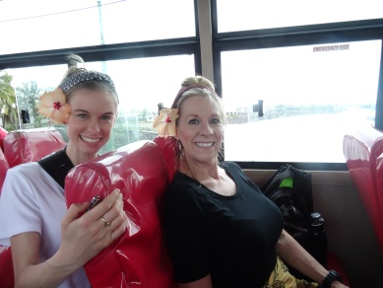
Who is going to grab a cab and miss the cultural experience of the local public transportation system? Cabs are for sissies. Jump on the bus and chat with locals about their favorite restaurants, activities, and sections of town. It will enrich your experience and also cause you to exercise, because you have to walk from the stop to wherever you want to go, rather than being dropped off at the door. Better yet, walk to as many places as you can and soak in the surroundings in the process!

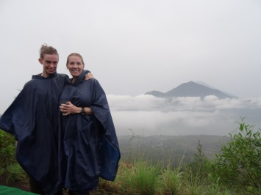
The point of adventure is to gain experiences. This means hiking, biking, boating, and of course a ton of walking. When my mom and I were in Bali, we climbed Mt. Batur. Yes, we got up at 2:30 am to hike a volcanic mountain in the rain, but it was an experience that we will cherish forever, and it did not cost much. This kind of thing is doable for most people; the only obstacle to truly overcome is the “I can’t do that” mindset that will keep us fat, broke and adventure-less.

How to lose weight, travel and save money (Resolution #3), all at one time

I know, I know, the response to this is, “but I can’t afford to take off to the Himalayas.” I must semi-respectfully disagree, without even knowing your financial situation.

Pick a destination that interests you, a place you have always wanted to go, and price it out. Better yet, call me and I will price it out at no cost to you. I can guide you on the most economical times of year to travel and the best times to buy airline tickets.

Once you have the cost in front of you, do not panic! Set a goal of how much money you want to save each week, and make it happen! Cutting out the daily Starbucks is a great starting place- not only is Starbucks expensive, it is chock full of calories that are packing on those pounds (see? Already getting started on the weight loss aspect).

Alcohol is another expensive indulgence that puts on the pounds. We can just cut that out and get drunk on the prospect of our upcoming adventure.

Another expensive cost? Dining out. To save money and lose weight, consider packing a healthy lunch for work, or watching a show while cooking dinner to make it fun. And no late night eating! Save the snack money and give your digestive system a break.

Get rid of the expensive gym membership, take a backpack and fill it with clothes, and walk around with it for 20 minutes every day (look at our website “resources” tab for a great backpack suggestion). This is a free way to lose weight, train your body for your upcoming adventure, and cut out another cost. Add some pushups and sit-ups after you walk. By the way, this is a radical advocacy for a Registered Nurse, which, of course, I am.

We all spend money on costs that add up without our knowledge--movie tickets, the very best cable package, the newest smart phone. The bottom line for saving money is to write down every single thing you buy and review it. Think “do I really need this right now?” and if the answer is “no,” cut it out. You will be surprised at the things you can live without and not even miss.

I promise, when you have planned an adventure, each time you spend money you will consider whether or not that item is a necessity to you. You might even find yourself maintaining this practice when you get back. If you want it to happen, it will happen.

So there you have it: how to combine those New Year’s resolutions to taste sweet success. I hope this inspires and helps you. Remember, if you put off the things that you really want to do, you will look up at the end of your life and regret the fact that you never did them. Life is meant to be lived to the fullest, so go live it!

To Adventure!

Tiger photo by Roger Smith, SD Safari Park 2015-9-12

